Brief steps for using DEMO software
- 1. Preparation work
1.1 Close WINODWS Firewall
1.2 Close virus software
1.3 Connect the RJ45 network port of the device to the switch, and the switch and computer are on the same local area network. Or use a network cable ,connect device and PC RJ45 port.
1.4 Device default IP is “192.168.1.15”
If the computer network is not in the same network segment, it is recommended to add a 1-segment IP to the computer network
2. DEMO software operation
2.1 Search for devices, find the device. The DEMO software uses UDP communication and can Use broadcast commands to search and then find a new device
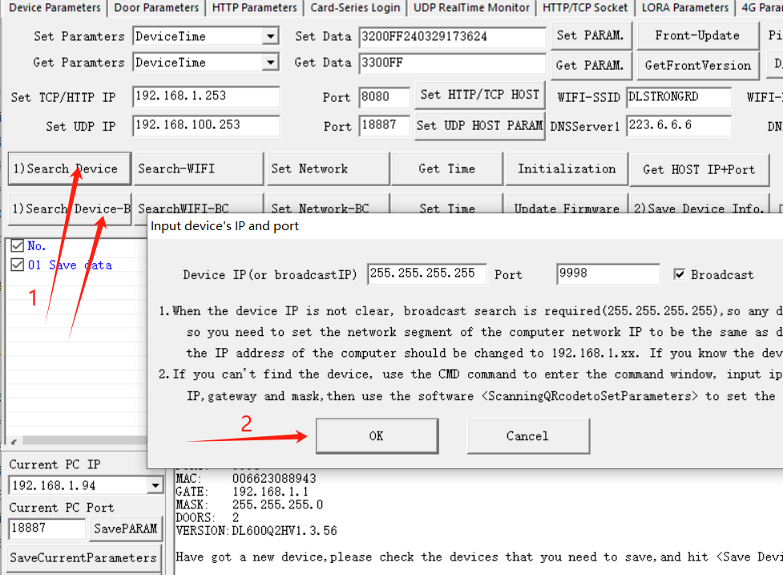

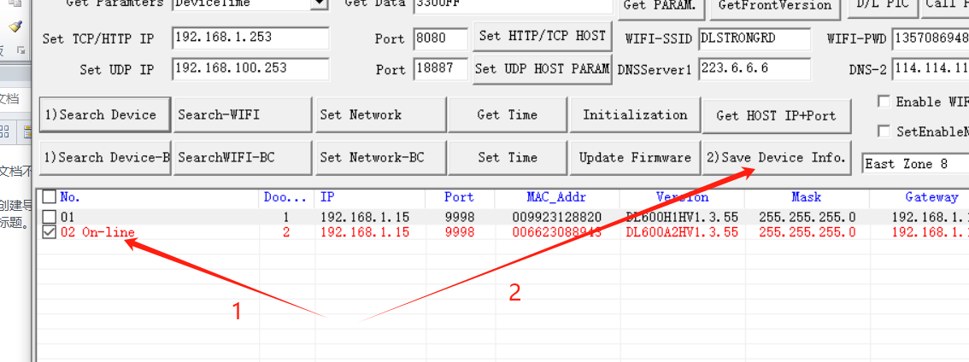

2.2 Set software server parameters
The device is the client mode, and the software platform is the server. As the client, the device will actively connect to the server, like a browser, by entering the website address to access the server website。
2.2.1 TCP Mode
Set the software platform TCP server IP and port, and then click "Get Host IP+port" to see the IP and port of the TCP server within the device, as well as the UDP server IP and port. DEMO uses UDP communication. If you want to view device data with UDP communication, you need to set the IP and port of the UDP server, which is the IP and port in the bottom left corner of the DEMO software, to the device. After set the IP address of the computer where the software (server) is located and the TCP server communication port, the device will actively connect to this TCP IP address and port。
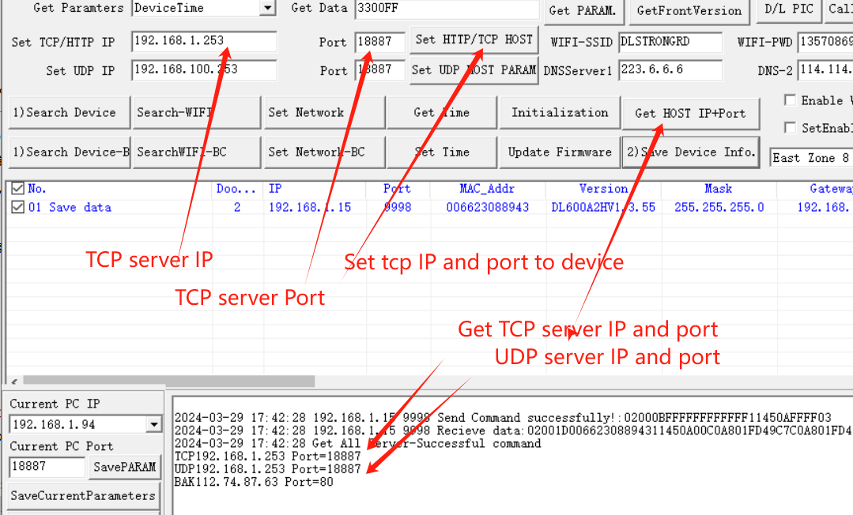

2.2.2 HTTP Mode
2.2.2 .1 Set the IP and port of the HTTP server
HTTP and TCP modes are the same, first the server IP and port of TCP/HTTP need to be installed. Same as 2.2.1。
2.2.2 .2 Set header parameters for HTTP servers
1）HTTP has three URI addresses，（1）OPEN URI（2）Event URI（3）Heart Beat URI
OPEN URI：That is to say, the URI address uploaded to the server by the device after receiving data such as QR code or card number, which is the webpage or address where the server processes and receives data such as device QR code or card number
Event URI：That is to say, when the device has internal history records, it requests the URI address for uploading history records from the server, which is the webpage or address that the server processes and receives history data from。
Heart Beat URI：The device will upload a "heartbeat" data to the platform within a fixed time interval (default of 30 seconds), telling the server that the device is working normally。
2）HOST Parameter: Enter the domain name or IP of the server here, and the HOST port will take the port number parameter from "HTTP Server IP and Port"。
3）The three URI request APIs of HTTP can be enabled or disabled, can be set, and are all enabled by default。
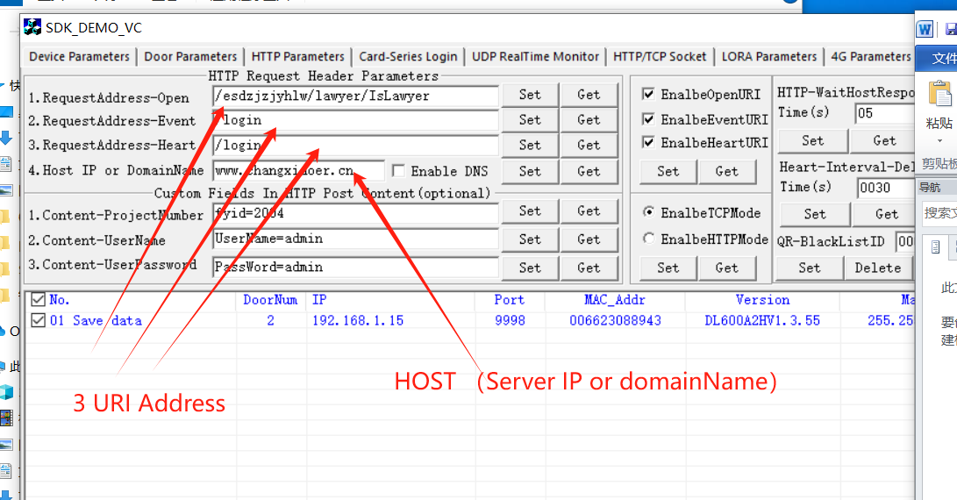

2.3 Using DEMO software, start the server (TCP server or HTTP server)
The software opens the server, and the server IP is the local IP. The port and the IP and port values set to the device are the same.After the software starts the server, the device can go to the software server。
