Instructions for operating the voice module to replace voice files
- 1. Materials: Prepare a Micro USB cable, a Phillips screwdriver, and a Windows computer
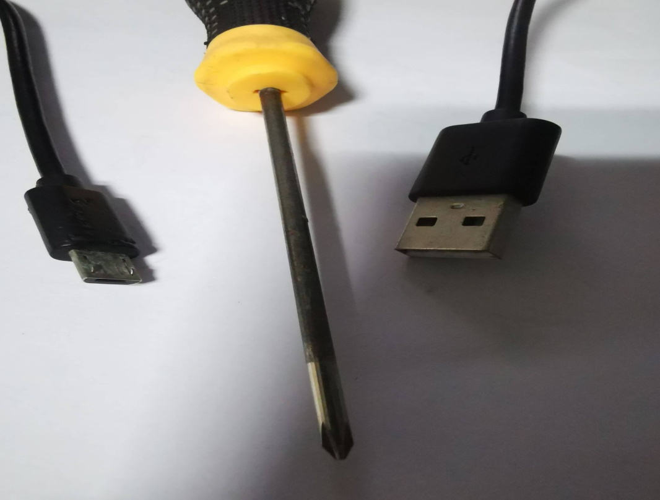

- Operation steps：
- 1) Move the back cover of the product away. There is an M3 screw at the bottom of the product, loosen it with a cross to allow the back cover to move away。
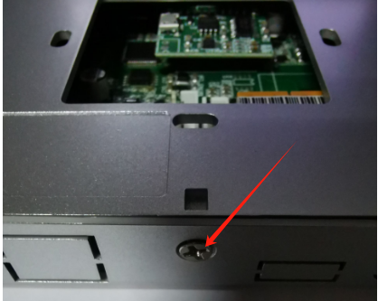

2）After opening the back cover, you can see a Micro USB port on the voice module. Insert the USB cable into the port, and then plug the other end of the USB cable into a computer USB socket
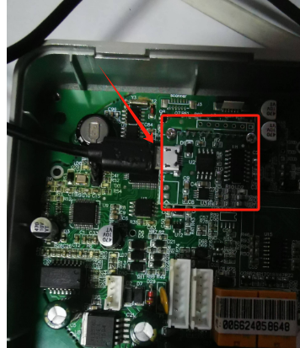
The device will be powered through this USB interface and a USB flash drive will be visible on the computer.On the left is a USB drive, and on the right are all the voice files in the “20220301” directory。
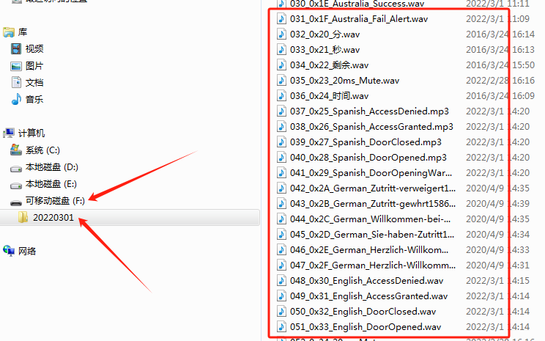

- How to add or change voice files?
- Copy the "20220301" directory from the USB drive and transfer it to a specific directory on the computer, such as the root directory of the D drive
- Let me explain: All voice file names in the "20220301" directory have a serial number in front of them, which is the playback address. For example, if the file
"066_ 0x42_Snglish-Please Go. wav" has a serial number of 66, then the playback address is 0x42=>decimal equals 66. Therefore, when naming a voice file, the corresponding serial number should be added in front of it to avoid disorderly file sorting。
- For example, we need to copy "LASER.wav" under WINDOWS Replace the WAV file with ，Then it will be 'LASER.WAV' Copy to the directory "20220301" As shown in the following figure
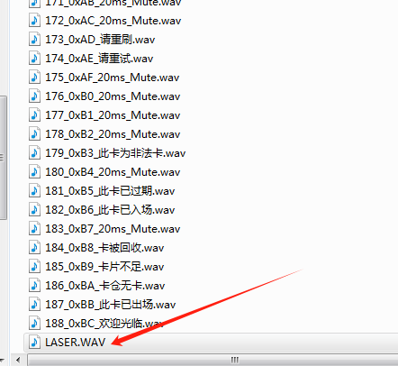
(4) rename the ”LASER.WAV”to ”012_0x0C_LASER.WAV”, As shown in the following figure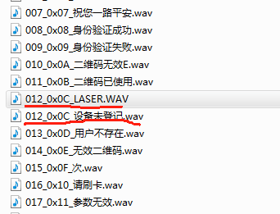

(5)then delete file, As shown in the following figure.
If you need to replace other files, just follow the steps in (3), (4), and (5) above. Remember to replace everything instead of deleting it, otherwise the calling address will be messy, because the address of the calling voice is the sorting number of the file.
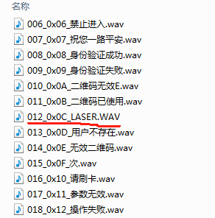
(6) Delete the "20220301" directory from the USB drive, or format the USB drive and then copy the edited "20220301" directory from the D drive to the USB drive. The final result is shown in the following figure. After unplugging the USB cable, you can call 0x0C for voice testing, and you will hear "LASER WAV "voice
